**ALAGAPPA COLLEGE OF TECHNOLOGY**

**ANNA UNIVERSITY-600025**

**NAAN MUDHALVAN ASSIGNMENT**

**DIGITAL MARKETING**

**Name:** Sara Nasrin S

**Roll No:** 2020308030

**Department:** B. Tech Pharmaceutical Technology

**College:** Alagappa College of Technology, Anna University.

**Naan Mudhalvan ID:**

**Zone:** Zone-1

**Assignment-1:**

Create a company name and design a poster and logo for that company.

Company Name: Flora’s Plant House

Company Description:

Company Type: Home and Garden

Logo:



Poster:



**Assignment-2:**

Create a blog describing your company.

Blog Link:

<https://florasplanthouse.blogspot.com/>

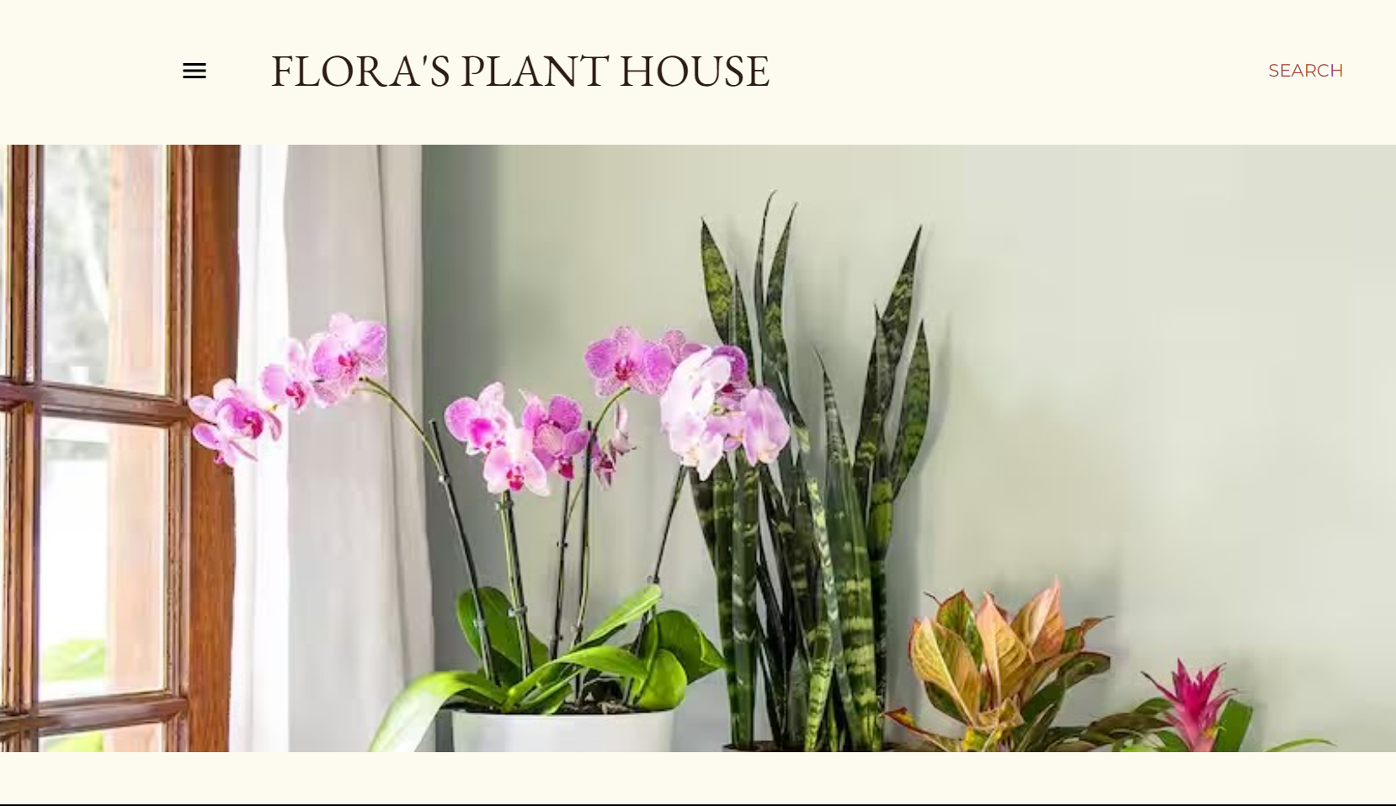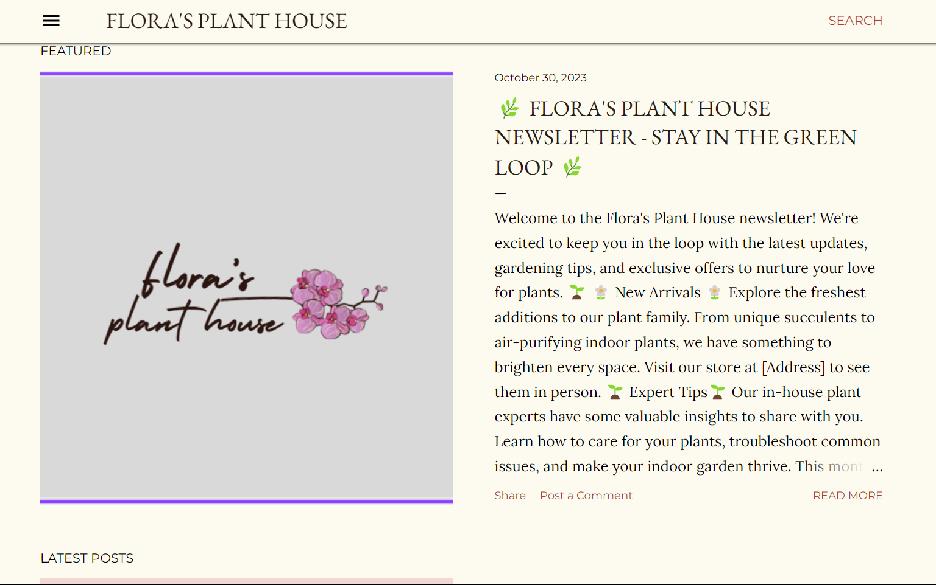

**Assignment-3:**

Create a Facebook account for your company

Facebook ID:

<https://www.facebook.com/profile.php?id=61552813474252>

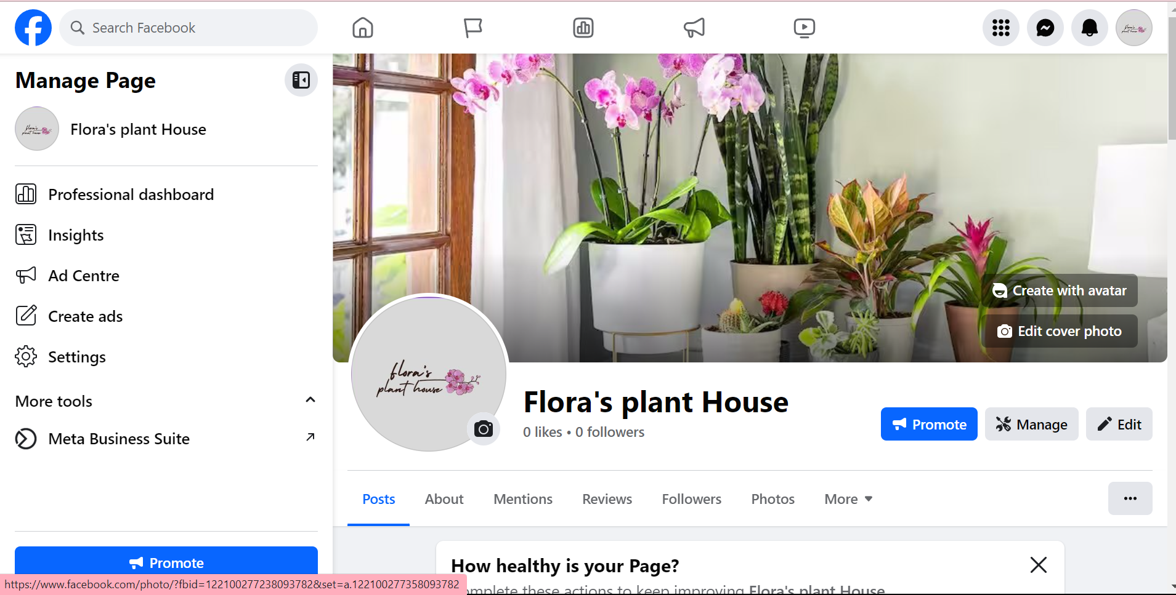

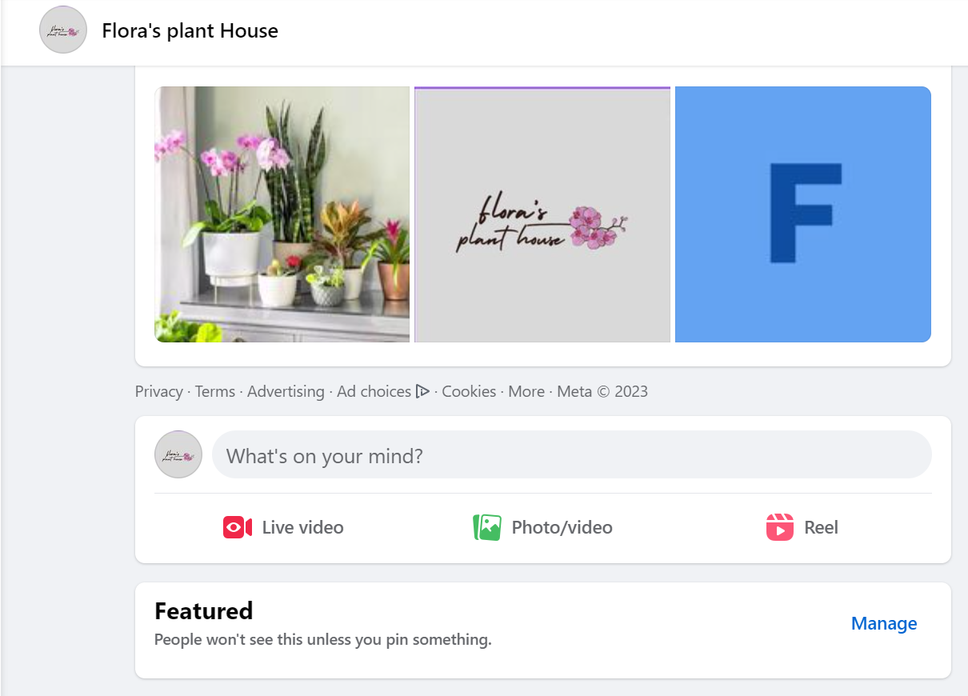

**Assignment-4:**

Create an Email Newsletter for your company and post it in your company blog site. Do google analytics for you blog and send google analytics id.

Google Analytics ID: G-X0FEKQVS7V

Email Newsletter link:

<https://florasplanthouse.blogspot.com/>

Email Newsletter:

